JAVASCRIPT EXERCISES

1.Create a form that collects the first name, last name, email, user id, password and confirm password from the user. All the inputs are mandatory and email address entered should be in correct format. Also, the values entered in the password and confirm password textboxes should be the same. After validating using JavaScript, display proper error messages in red color just next to the textbox where there is an error.

2.Display a message "Welcome!!!" on your webpage and when the user hovers over the message, a popup should be displayed with a message "Welcome to my WebPage!!!".

3.Experiment 1 (HTML Page)
I. (a) Create a webpage with HTML describing your department. Use paragraph and list tags.
(b) Apply various colors to suitably distinguish key words. Also apply font styling like
italics, underline and two other fonts to words you find appropriate. Also use header tags.
(c) Create links on the words e.g. “Wi-Fi” and “LAN” to link them to Wikipedia pages.
(d) Insert an image and create a link such that clicking on image takes user to other page.
(e) Change the background color of the page. At the bottom create a link to take user to the
top of the page.
Experiment 2 (Tables)
I. (a) Create a table to show your class time-table.
(b) Use tables to provide layout to your HTML page describing your university
infrastructure.
(c) Use <span> and <div> tags to provide a layout to the above page instead of a table
layout.
(d) Use frames such that page is divided into 3 frames 20% on left to show contents of
pages, 60% in center to show body of page, remaining on right to show remarks.
(e) Embed Audio and Video into your HTML web page.
Experiment 3 (CSS)
I. (a) Apply in-line CSS to change colors of certain text portion, bold, underline and italics
certain words in your HTML web page. Also change background color of each paragraph
using in-line CSS.
(b) Write all the above styling in CSS in different file (.css) and link it to your webpage such
that changes made in CSS file are immediately reflected on the page. Group paragraphs
into single class and add styling information to the class in CSS.
(c) Create a simple form to submit user input like his name, age, address and favorite
subject, movie and singer.
(d) Add few form elements such as radio buttons, check boxes and password field. Add a
submit button at last.
2
Experiment 4 (JavaScript)
I. (a) Create a form similar to the one in previous experiment. Put validation checks on values
entered by the user using JavaScript (such as age should be a value between 1 and 150).
(b) Write a JavaScript program to display information box as soon as page loads.
(c) Write a JavaScript program to change background color after 5 seconds of page load.
(d) Write a JavaScript program to dynamically bold, italic and underline words and phrases
based on user actions.
(e) Write a JavaScript program to display a hidden div (e.g. showing stats of a player when
user clicks on his name).

- 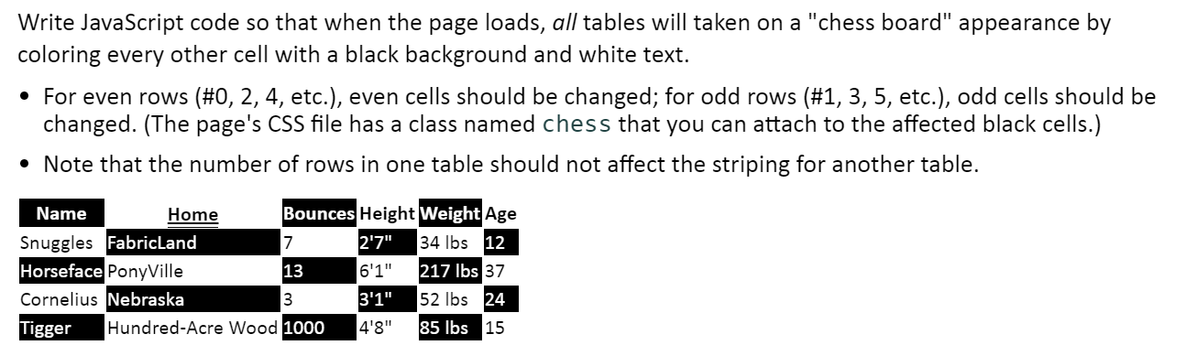

6.

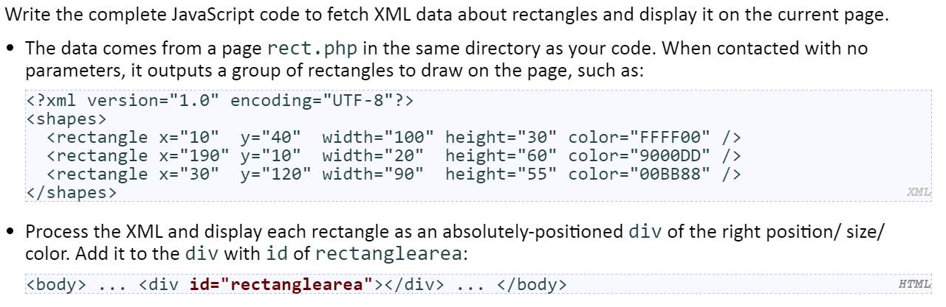

7. Write a javascript code
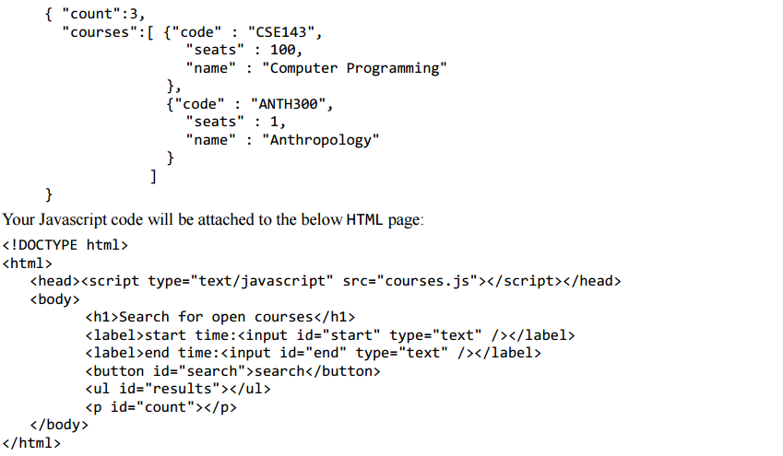

- Write JavaScript code in a file called simple.js for manipulating a list. The page UI allows the user to type some text into a text box. The user can click an "add" button to make the text appear in the list (put it inside the game div). When the mouse enters a list item the background color of that item should turn cyan and the font size of that list item should increase by 5px. When it leaves that item the background color should turn back to white and the font size back to what it originally was. The original font size is included in a CSS file attached to the HTML. Your code should work for any starting font size value. You can view the current size with your code but not by opening the file and looking at it. When the user clicks on an item it should be deleted. You may not use any Javascript libraries such as Prototype and JQuery. You must write ALL Javascript to make the page work, none is provided. You can define any additional CSS you like as long as you label it in a clear way. You only need to write the appearance/CSS changes mentioned above. You can assume the page has a linked style sheet that provides the other styles visible in the screenshots.

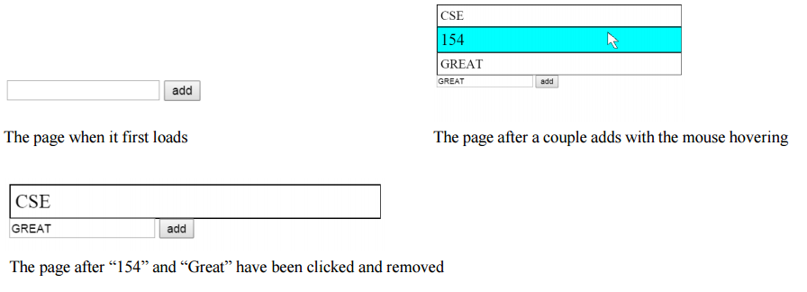

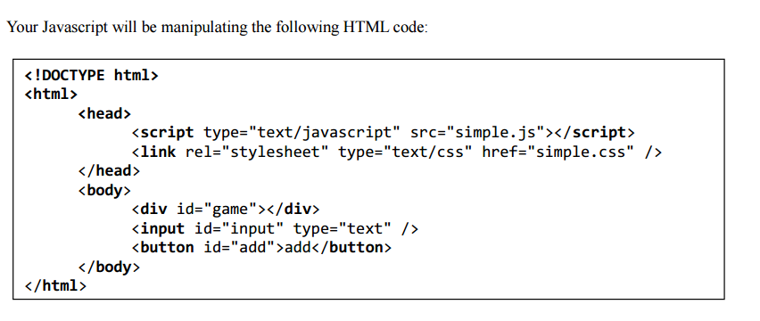

- Write the JavaScript code to add behavior to the following page for keeping track of a to-do-list. The page UI allows the user to type an item into a text box. The user can click the "add" button to add the item to the bottom of the list. Each word in the phrase should be inserted as a li, inside a ul with the id of list.
If the user wishes to remove an item he or she can type the text of the item he or she wishes to remove in the text box and click the “remove” button. This should be case insensitive. For example, if the list only contains “foo” and the user tries to remove “FoO”, it should be removed. If the user tries to remove an item that is in the list multiple times only the first occurrence should be removed.
The items should have background colors that alternate between white and yellow (first white, then yellow, then white, yellow, etc.). This should still be the case no matter how many items are removed or added and no matter what order these operations are done in. You may not use the CSS3 nth-child pseudo selector to do this. The code should work for multiple clicks of the buttons. On each click it should clear any previous information you typed in the input boxes. Do not use any JavaScript libraries such as jQuery or Prototype. Here is the relevant HTML code for the page:

